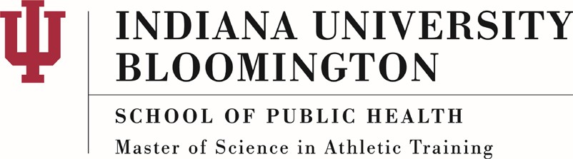

MSAT Admission Requirements
- Bachelor’s degree
Students must have completed a bachelor’s degree from an accredited institution prior to enrolling in the MSAT program. Applicants with a degree in health-related field will be given priority consideration. Undergraduate students at Indiana University-Bloomington planning to apply to the MSAT program are encouraged to major in Exercise Science in the Department of Kinesiology within the School of Public Health.

- Prerequisite coursework
Coursework in the following in areas, with a minimum grade of “C” is required.
  - Human Anatomy (with lab)
  - Human Physiology (with lab)
  - Chemistry
  - Exercise Physiology
  - Biology
  - Physics
  - Biomechanics
  - Human Nutrition
  - Psychology
  - Statistics

Additional coursework in the following areas is highly recommended.
  - Emergency care
  - Introduction to athletic training
  - Epidemiology
  - Strength & Conditioning
  - Ethics

- Completed SOPHAS application and Bloomington Online Graduate Admissions Application
Applications are open from September 1st through April 1st. Applications completed by January 15th will be given priority consideration.

- Three (3) letters of recommendation

- Statement of purpose and response to school specific questions

- Resume/CV

- Completed GRE
- First Aid & CPR certification
- International Students: TOEFL or IELTS exam
- Interview with MSAT faculty by invitation

